Task on Docker -03
- Create a image from running container.
Connected to instance:
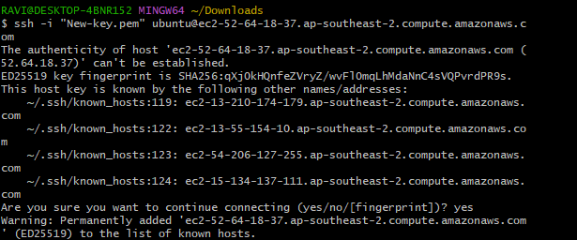
Used docker ps and docker ps -a
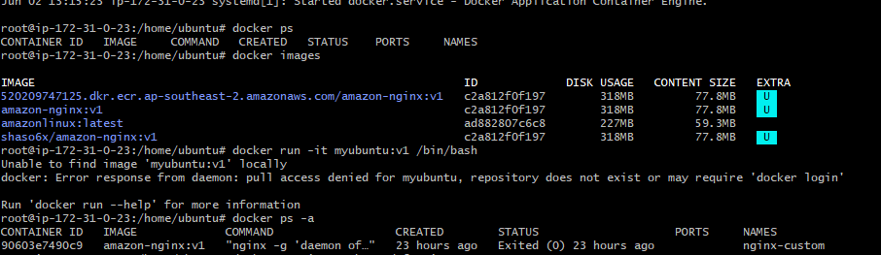
Used the below commands:
docker commit 90603e7490c9 amazon-nginx:v1
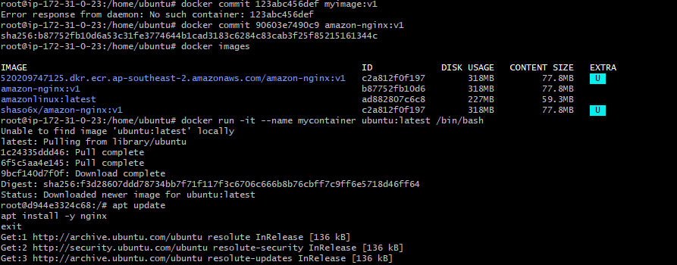
Installed nginx:
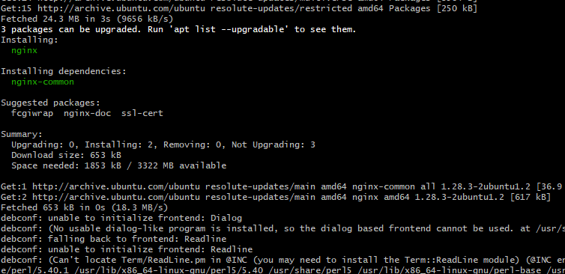
docker commit mycontainer myubuntu-nginx:v1
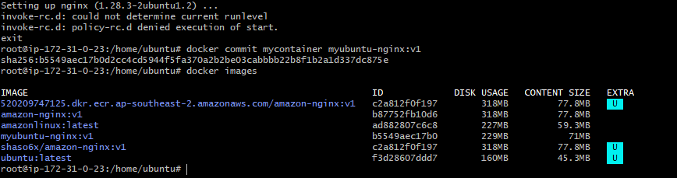
- Copy image from local machine to docker server and load the image.
docker save -o myubuntu-nginx-v1.tar myubuntu-nginx:v1
Ls -lh
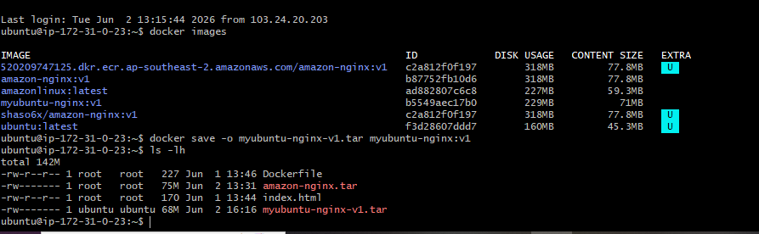
> Remove Existing Container Using Image
docker ps -a
docker rm -f nginx-custom-v2
docker rmi nginx-custom:v2
docker images
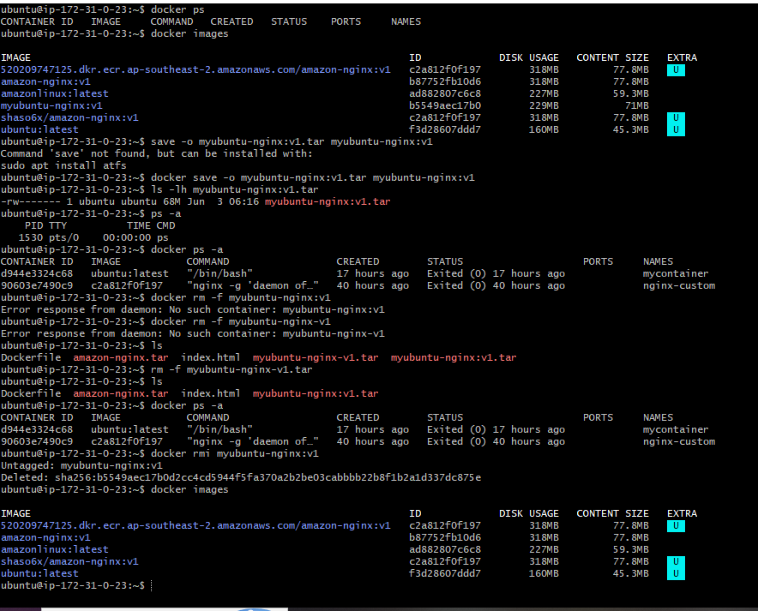 docker load -i myubuntu-nginx:v1.tar
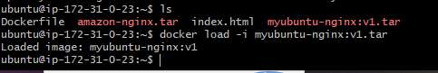
> Run a new container
docker run -itd \
--name nginx-loaded \
-p 8081:80 \
myubuntu-nginx:v1
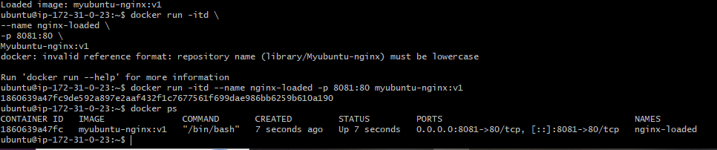
- Create Docker image using alpine and customize with tomcat.
Check vi version and then > sudo docker build -t alpine-tomcat:v1 .
Created a file with dockerfile name and then inserted the below steps:
FROM alpine:latest

# Install Java, wget, and tar
RUN apk add --no-cache openjdk17-jre wget tar

# Download and install Tomcat
RUN wget https://dlcdn.apache.org/tomcat/tomcat-9/v9.0.118/bin/apache-tomcat-9.0.118.tar.gz && \
tar -xzf apache-tomcat-9.0.118.tar.gz && \
mv apache-tomcat-9.0.118 /opt/tomcat && \
rm apache-tomcat-9.0.118.tar.gz

EXPOSE 8080

CMD ["/opt/tomcat/bin/catalina.sh", "run"]
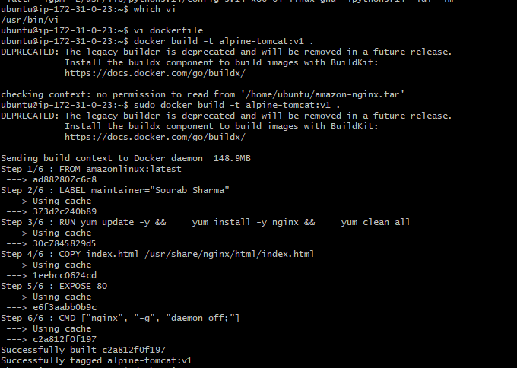 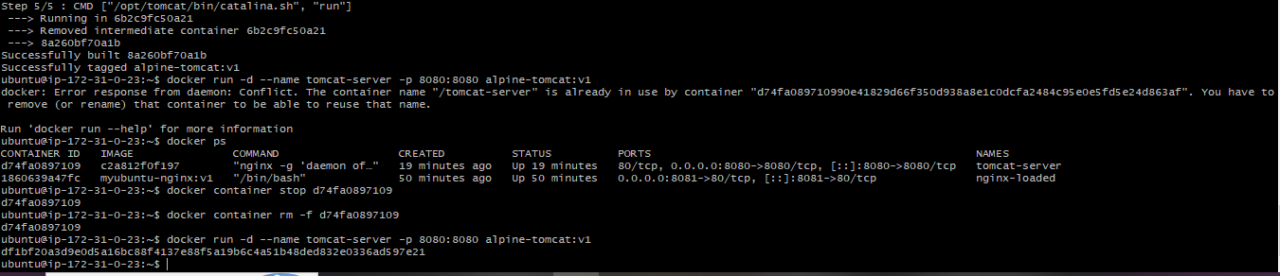
docker run -d --name tomcat-server -p 8080:8080 alpine-tomcat:v1
docker ps
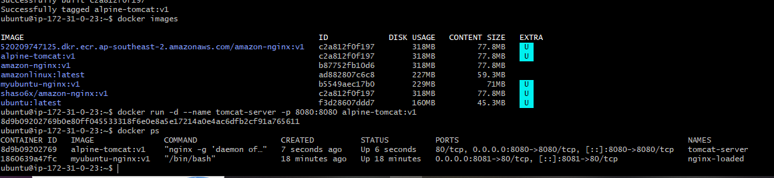
Checked in the browser as well:
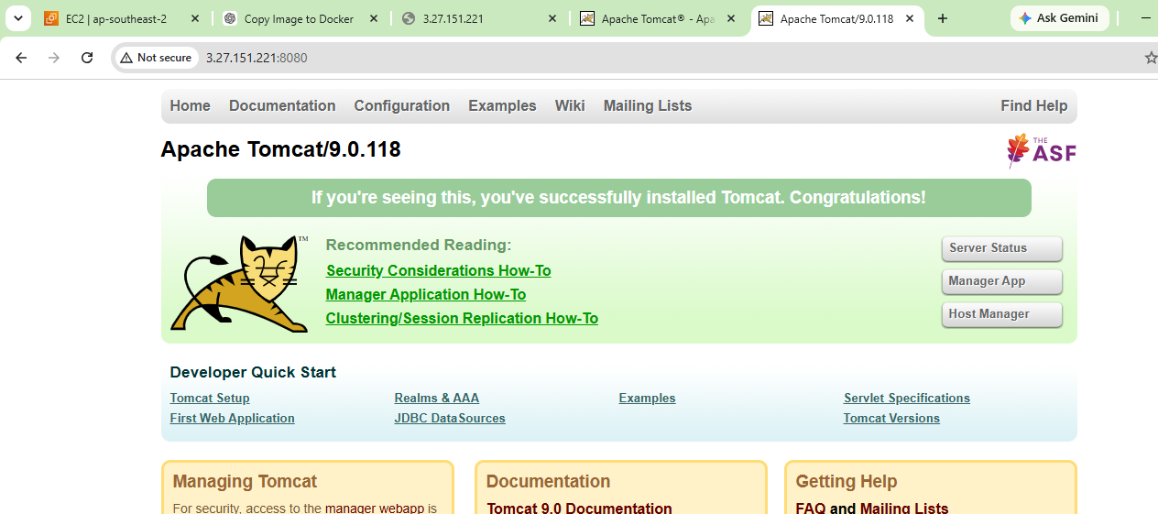
- Create single stage and multi stage docker file using this source code:https://github.com/betawins/multi-stage-example.git
cd multi-stage-example
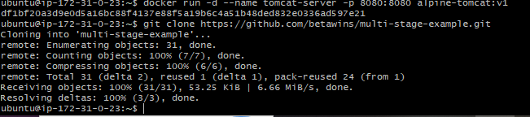
Single Stage Dockerfile
> Create Dockerfile
vi Dockerfile
> build image
docker build -t springboot-single:v1 .
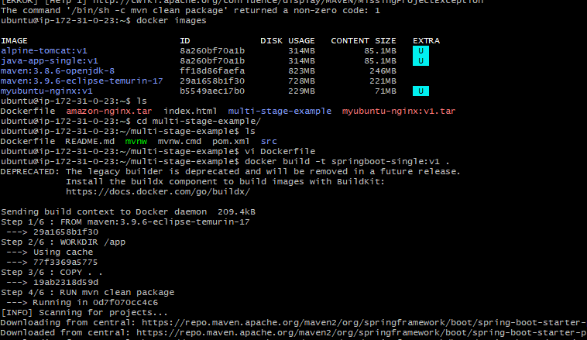
Docker images:
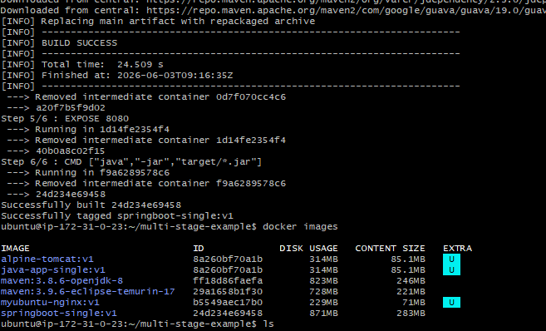
docker build -t springboot-multi:v1 .
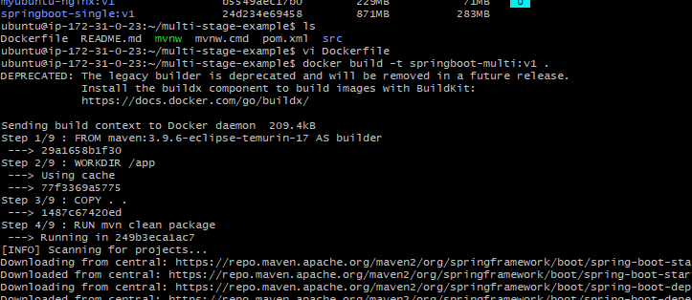
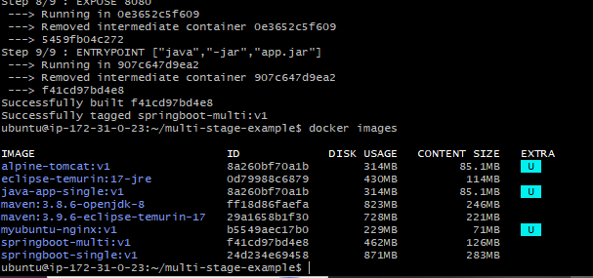
- Install docker compose and execute sample application.
sudo apt install docker-compose-v2 -y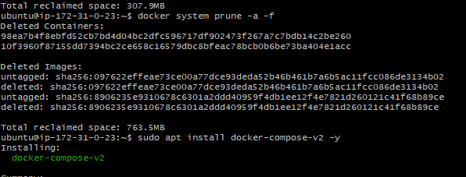
vi docker-compose.yml
docker compose up -d
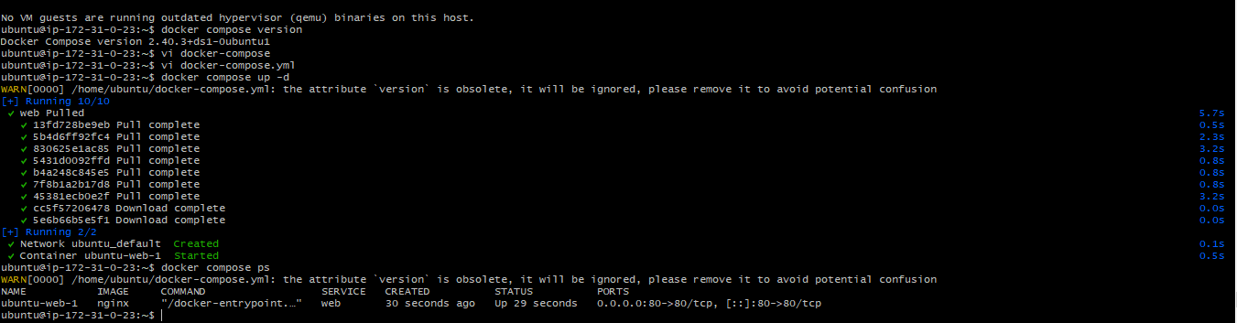
Then verify with the ip and 80 port number:
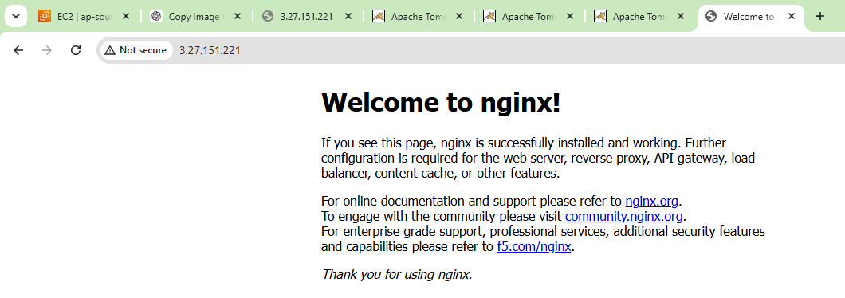
- Implement solution to scan images when pushed to docker registry.
sudo docker build -t amazon-nginx:v1 .
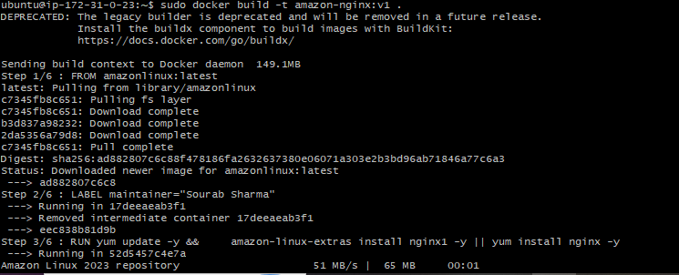
docker images
docker tag amazon-nginx:v1 shaso6x/amazon-nginx:v1
docker push shaso6x/amazon-nginx:v1
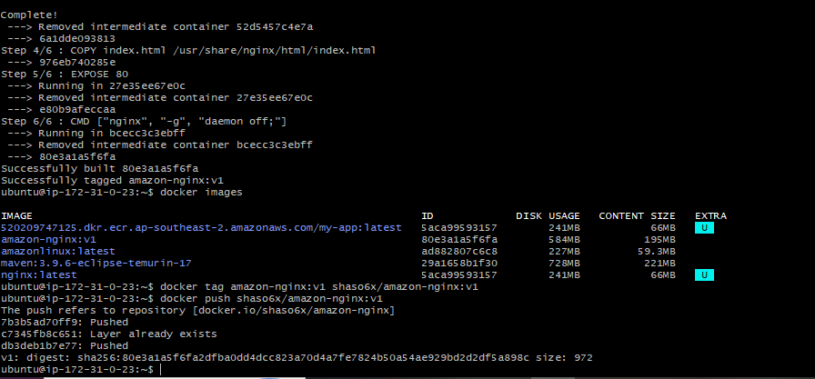
Docker scan option enabled for the new images: 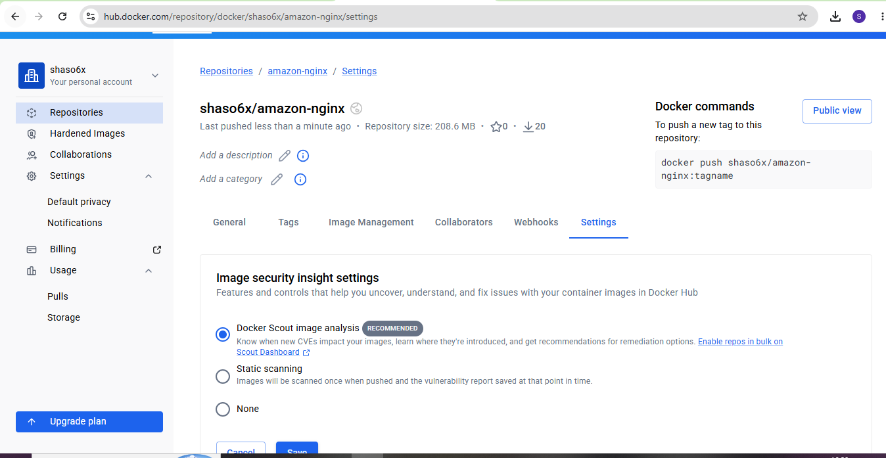
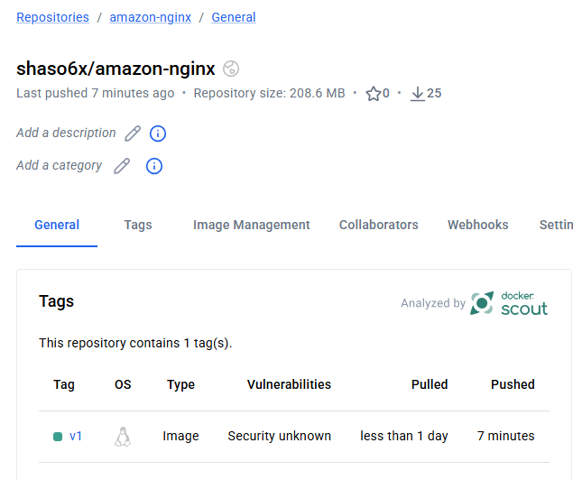
- Implement solution to scan images when pushed to AWS ECR.
> Open AWS ECR
> Go to features and settings
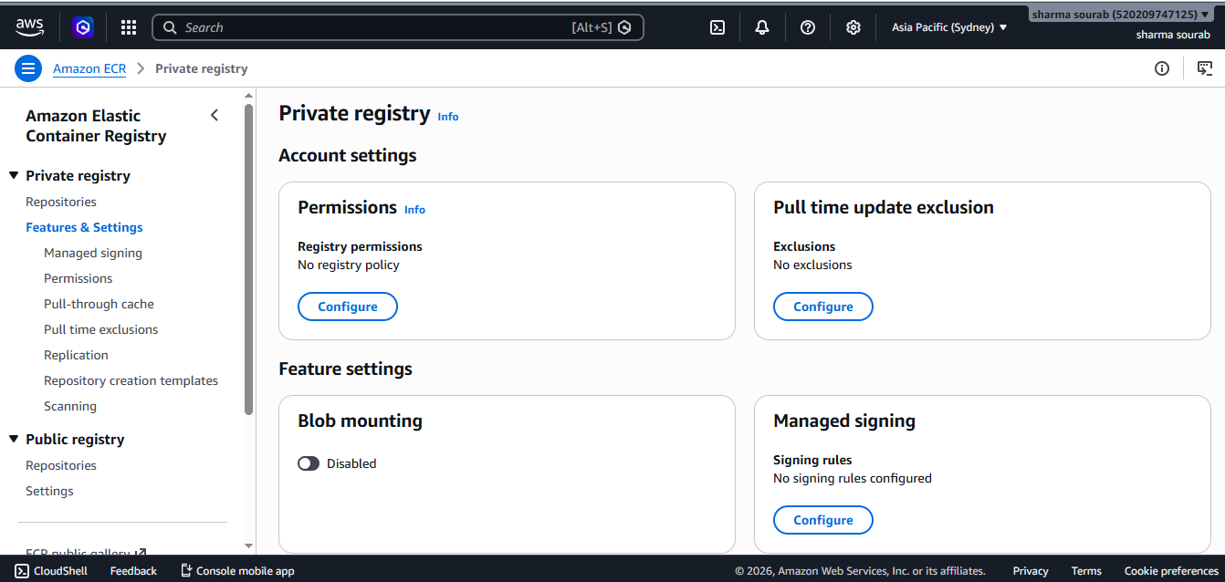
> we are turning on the scanning
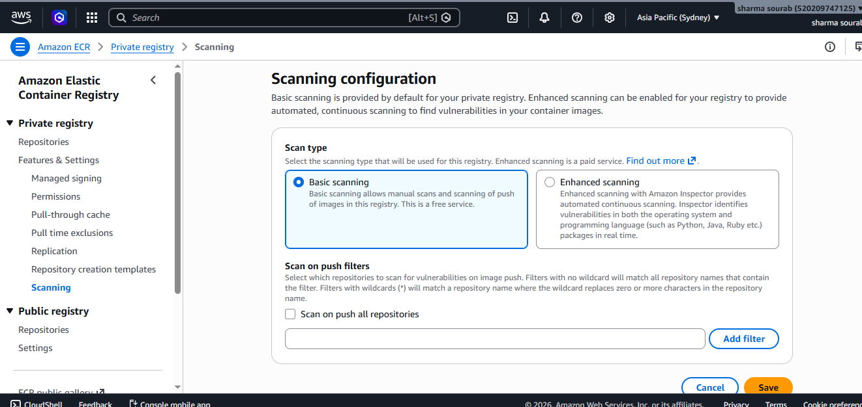
> Whenever there is new image push to ECR those will be scanned automatically
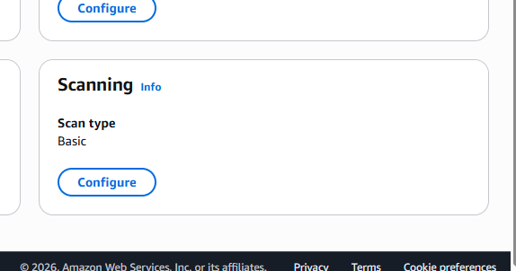
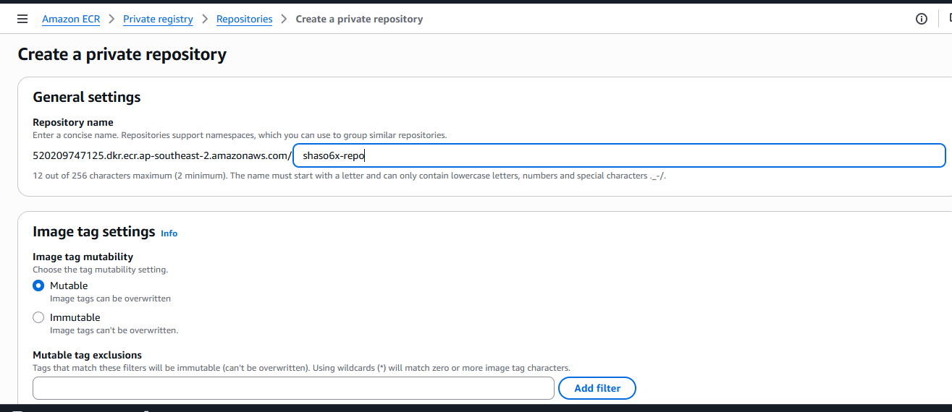
aws ecr get-login-password --region ap-southeast-2 | \
docker login --username AWS --password-stdin \
520209747125.dkr.ecr.ap-southeast-2.amazonaws.com
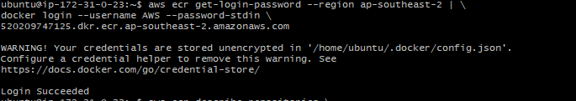
aws ecr describe-repositories \
--repository-names my-app \
--region ap-southeast-2
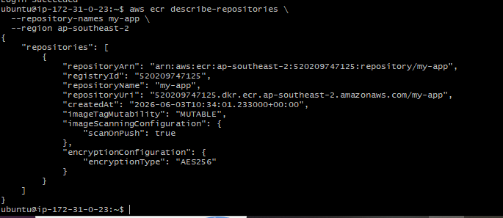
> Tagging a image and pushing it to ecr
docker tag amazon-nginx:v1 520209747125.dkr.ecr.ap-southeast-2.amazonaws.com/shaso6x-repo:v1
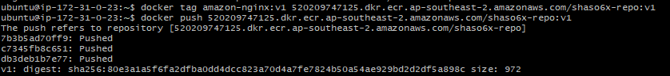
docker push 520209747125.dkr.ecr.ap-southeast-2.amazonaws.com/shaso6x-repo
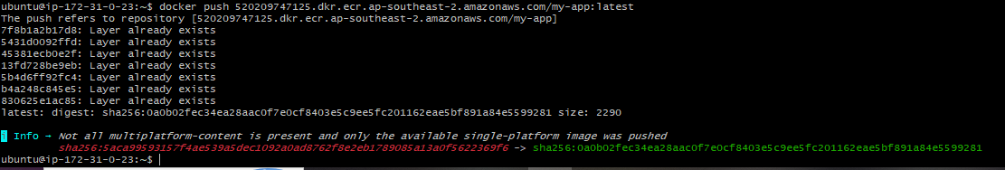
> Amazon ECR → Repositories → nginx-scan →
Images → latest → Scan Findings
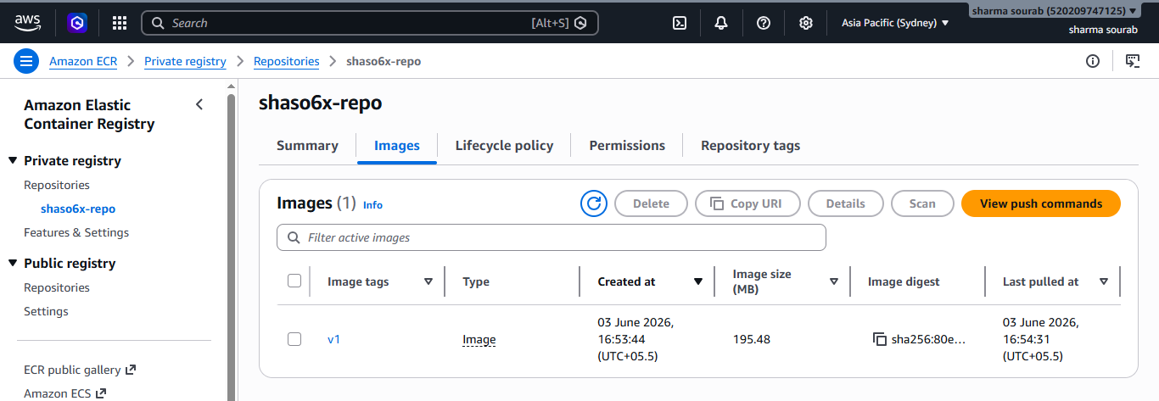
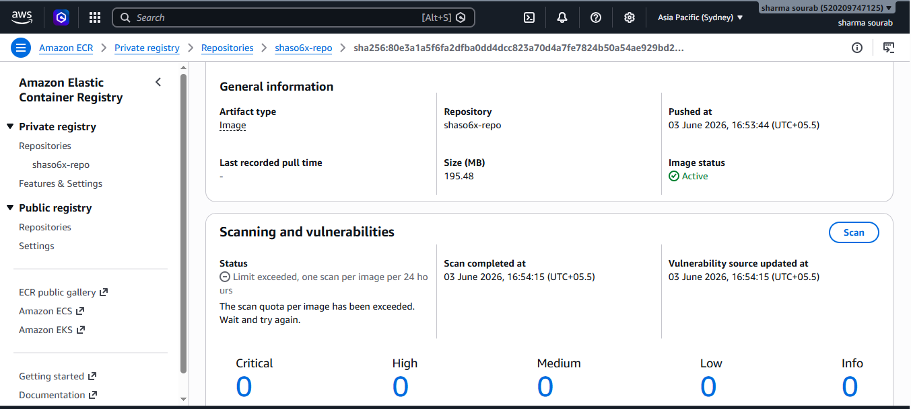
- Create a Jenkins pipeline to create a docker image and push the image to Docker hub.
→Start Jenkins Container
docker run -d \
--name jenkins-server \
--restart unless-stopped \
-p 9090:8080 \
-p 50000:50000 \
-v jenkins_home:/var/jenkins_home \
-v /var/run/docker.sock:/var/run/docker.sock \
-u root \
jenkins/jenkins:lts
docker start jenkins-server
docker logs jenkins-server
docker exec -it jenkins-server cat
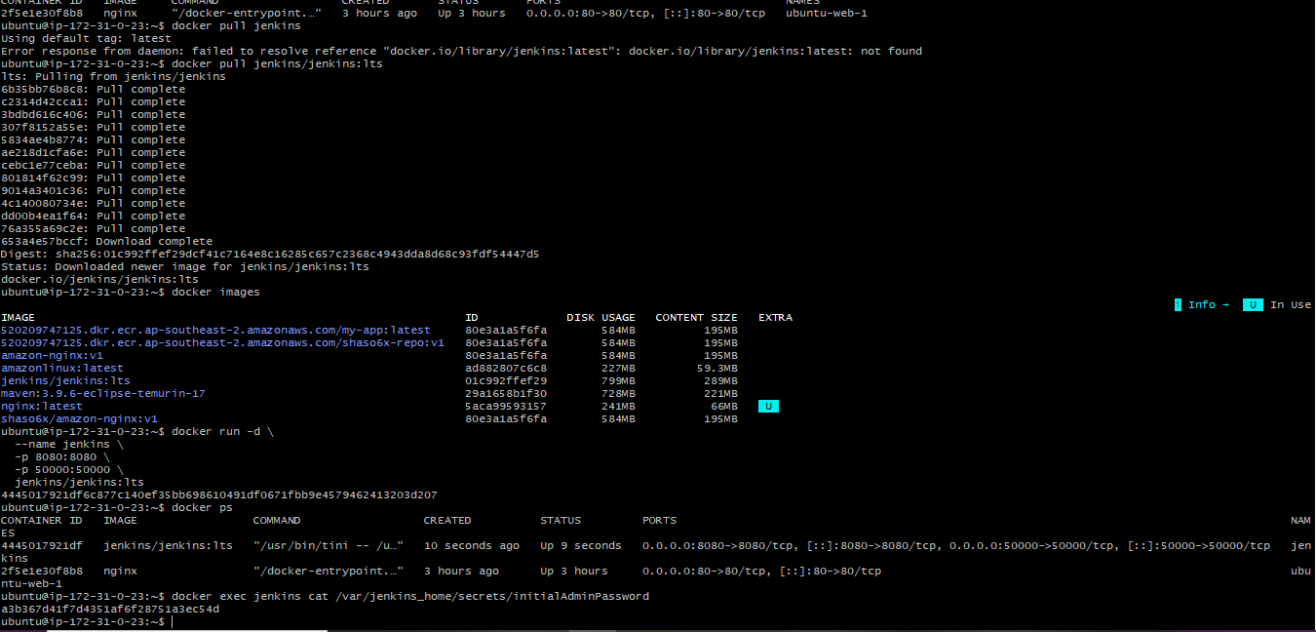
docker exec jenkins cat /var/jenkins_home/secrets/initialAdminPassword
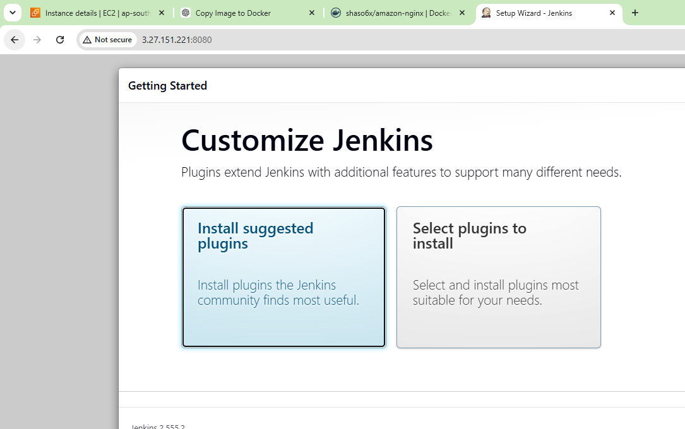
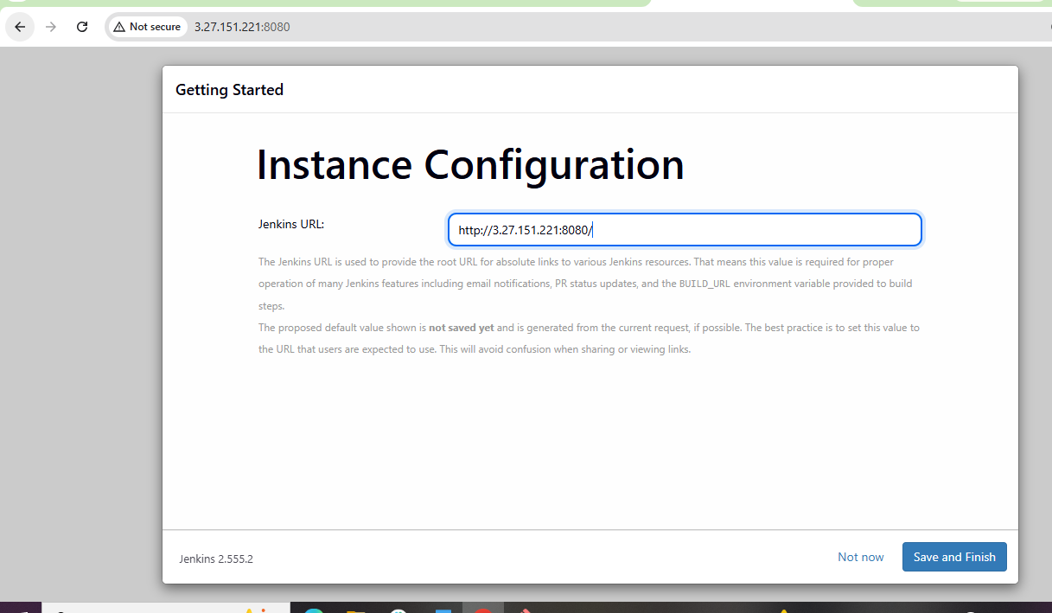
Installing docker plugins
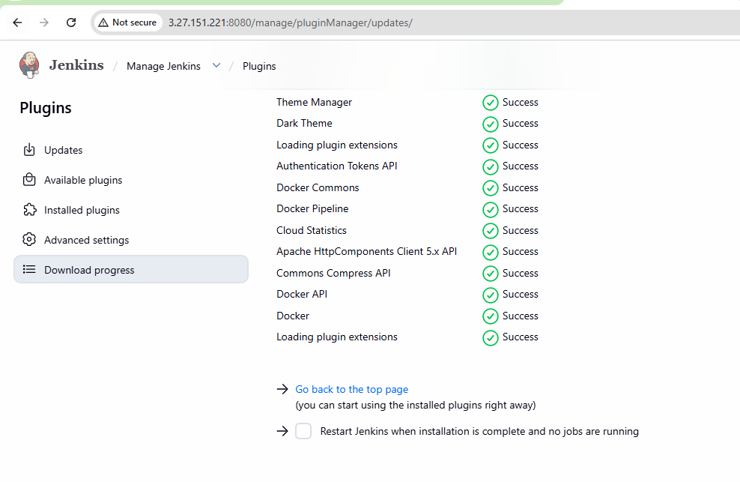
Add Docker Hub Credentials
Manage Jenkins→ Credentials → System→ Global
Credentials → Add Credentials
Before adding this credentials we need to generate the access token in docker hub: 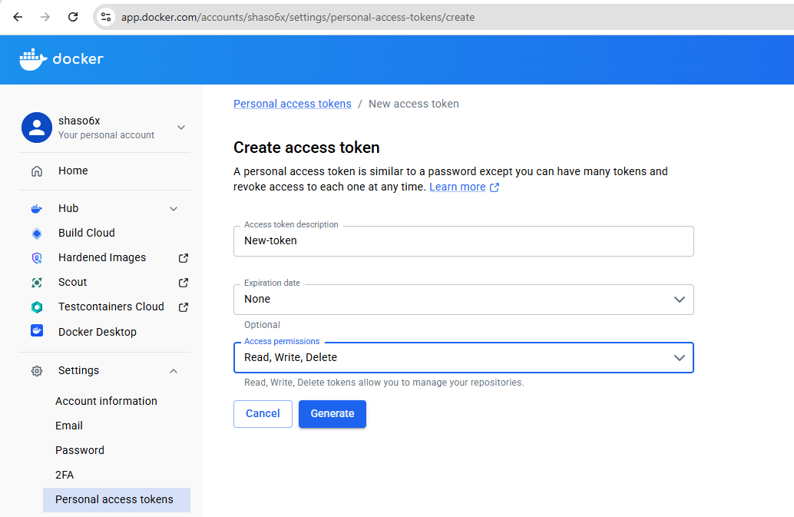
Once it is done add the credentials with username shaso6x and the password is the access token password:
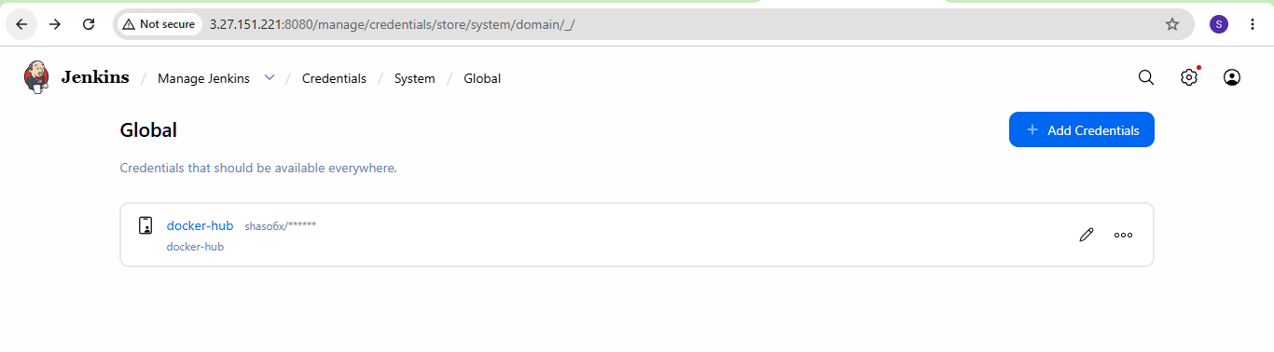
Create Pipeline Job
pipeline {
agent any

stages {

stage('Clone Code') {
steps {
git branch: 'master',
url: 'https://github.com/betawins/multi-stage-example.git'
}
}

stage('Create Dockerfile') {
steps {
writeFile file: 'Dockerfile', text: '''
FROM maven:3.8.6-openjdk-8 AS builder
WORKDIR /app
COPY . .
RUN mvn clean package

FROM eclipse-temurin:8-jre
WORKDIR /app
COPY --from=builder /app/target/*.jar app.jar
EXPOSE 8080
ENTRYPOINT ["java","-jar","app.jar"]
'''
}
}

stage('Build Docker Image') {
steps {
sh 'docker build -t shaso6x/nginx-custom:v3 .'
}
}

stage('Docker Hub Login') {
steps {
withCredentials([usernamePassword(
credentialsId: 'dockerhub-creds',
usernameVariable: 'DOCKER_USER',
passwordVariable: 'DOCKER_PASS'
)]) {
sh 'echo $DOCKER_PASS | docker login -u $DOCKER_USER --password-stdin'
}
}
}

stage('Push Docker Image') {
steps {
sh 'docker push shaso6x/nginx-custom:v3'
}
}
}
}

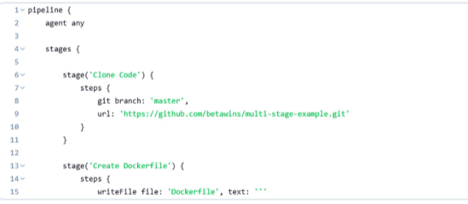
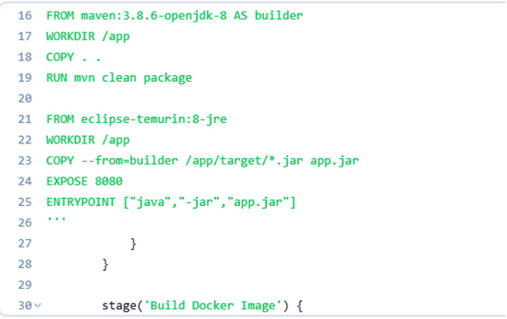
Build success 